**EXPERIMENT 1**

**RESONANCE IN SERIES AND PARALLEL CIRCUITS**

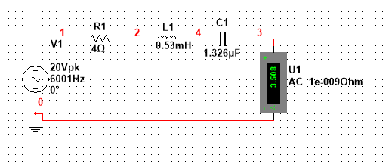

**CIRCUIT 1**

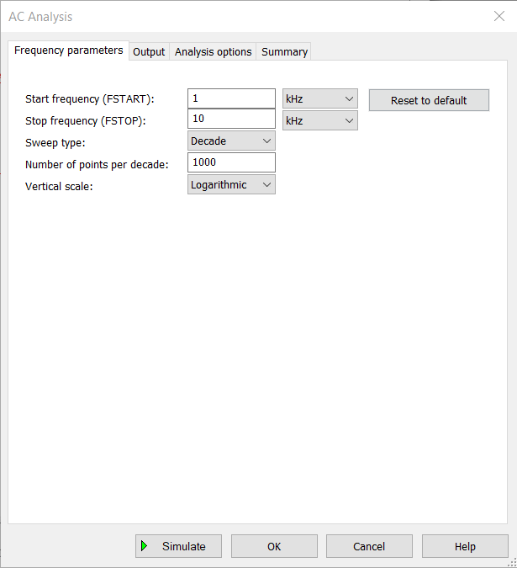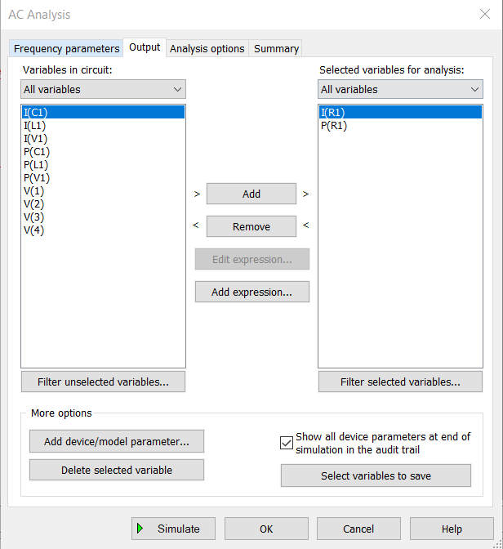

**PARAMETERS FOR ANALYSIS**

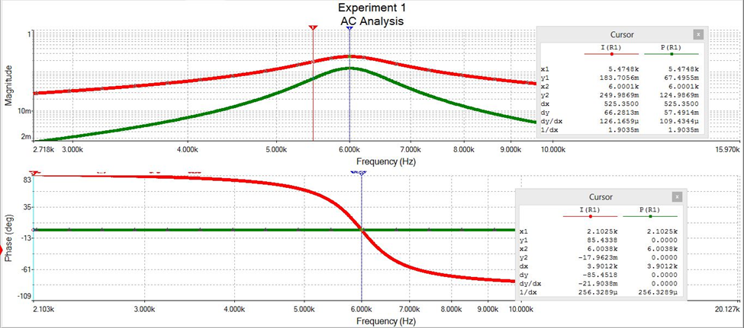

**GRAPH 1**

The theoretical resonant frequency for the circuit is 6000 Hz, but the value as calculated from the graph from AC analysis of the circuit is 6001 Hz, which is very clos to the theoretical value. The theoretical calculation for the resonant frequency is given below:

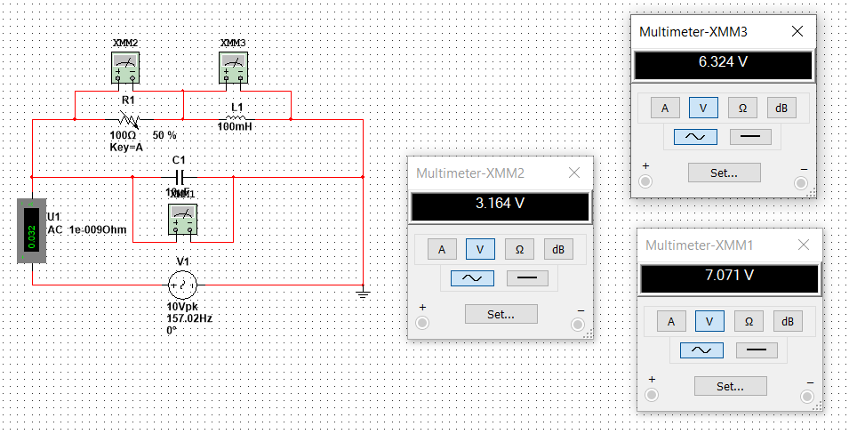

**CIRCUIT 2**

**The voltage across 100 Ω resistor is 3.164 V, 100mH inductor is 6.234 V and 10uF capacitor is 7.017 V.**

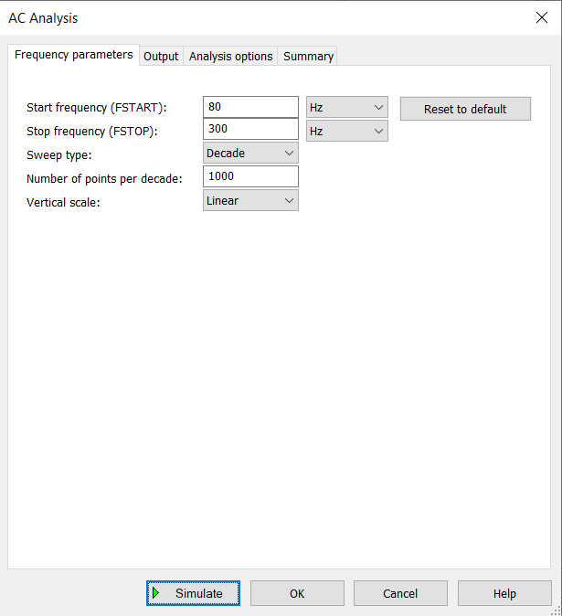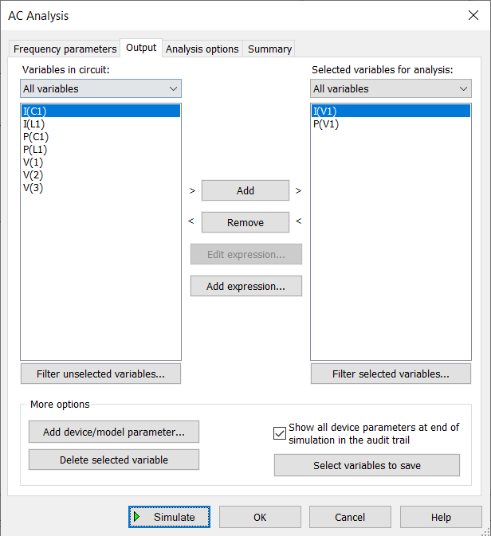

**PARAMETERS FOR ANALYSIS**

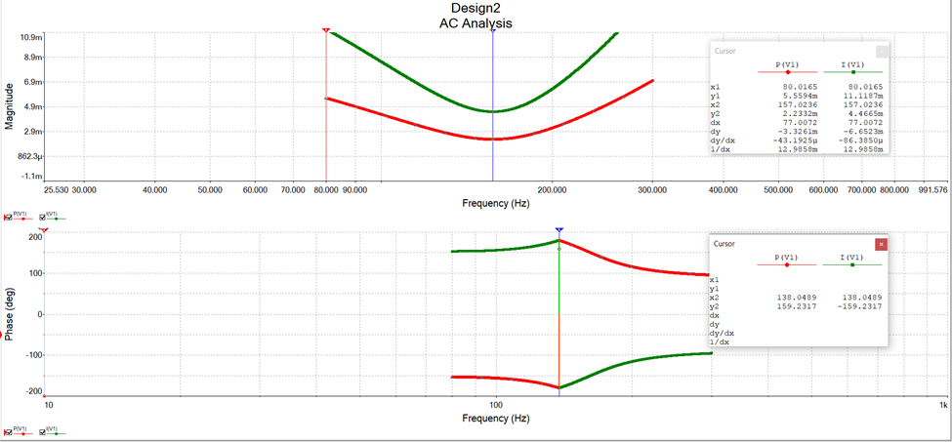

**GRAPH FOR CIRCUIT 2**

**The theoretical frequency of the above parallel circuit comes out to be . From the Multisim simulator, the value of resonating frequency is 157.0236 Hz, which is very close to the theoretical value.**

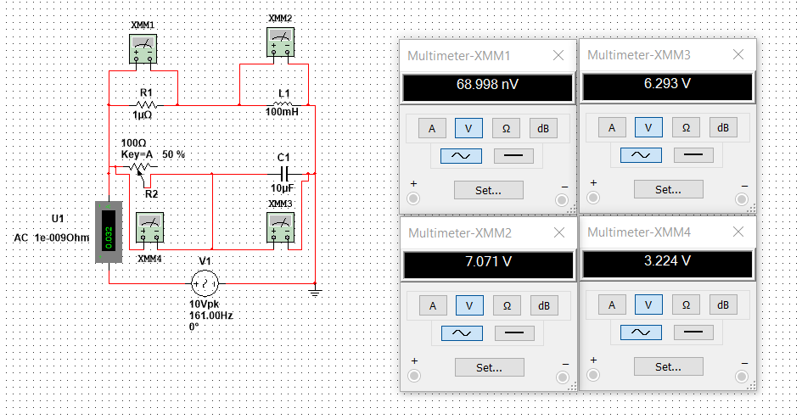

**CIRCUIT 3**

**Voltage across R1 (1µΩ) is 68.998 nV, 100mH inductor is 7.071 V, 50Ω Resistor R2 is 3.224 V and 10µH capacitor is 6.293V. AC current through the circuit is 0.032 A**

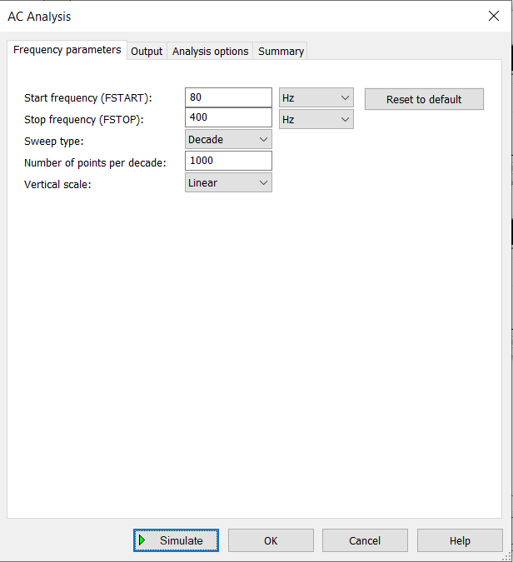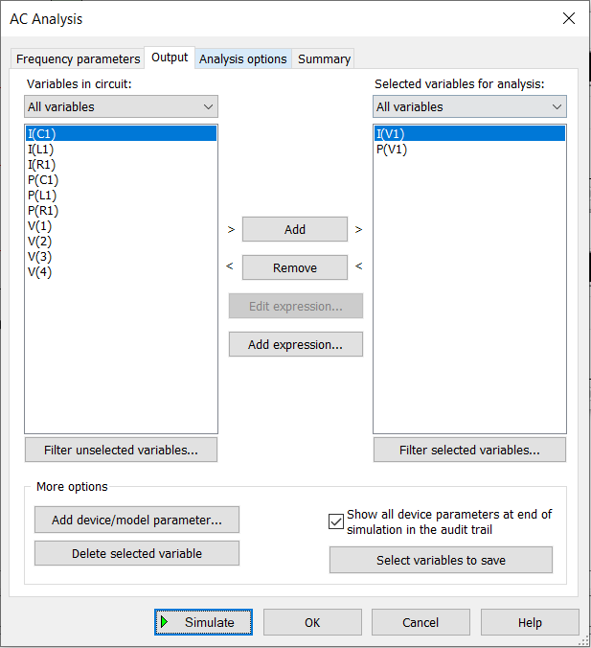

**PARAMETERS FOR ANALYSIS**

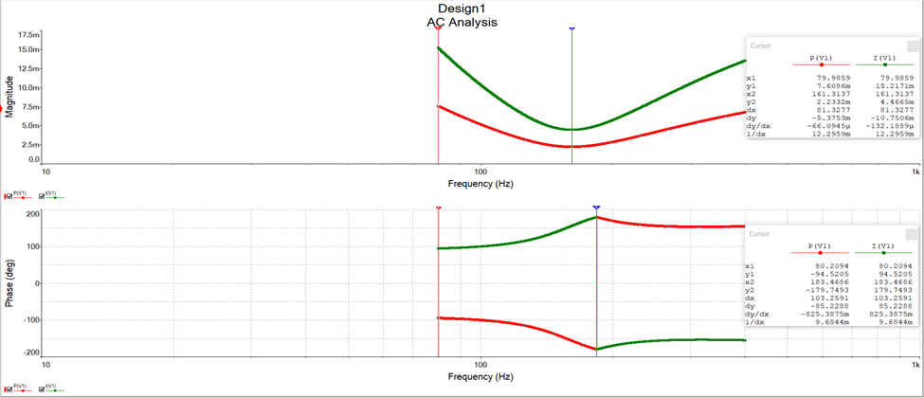

**GRAPH FOR CIRCUIT 3**

**From the AC analysis of the circuit, the resonant frequency of the circuit comes out to be 161.00 Hz. The theoretical value of resonant frequency comes out to be**

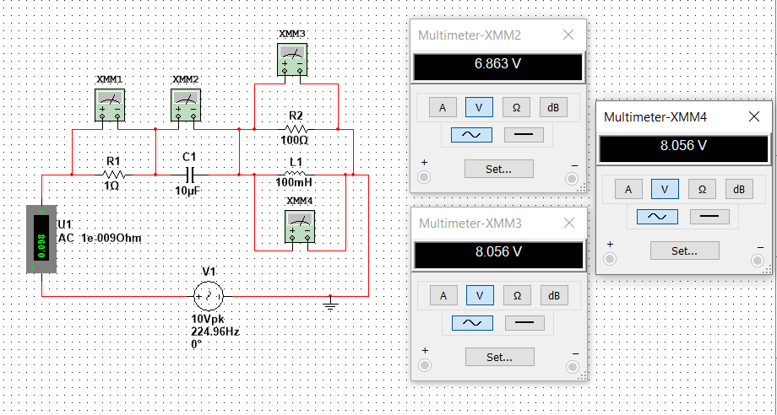

**CIRCUIT 4**

**Voltage across 10µF capacitor is 6.863V, 100Ω Resistor is 8.056V and 100mH inductor is 8.056V**

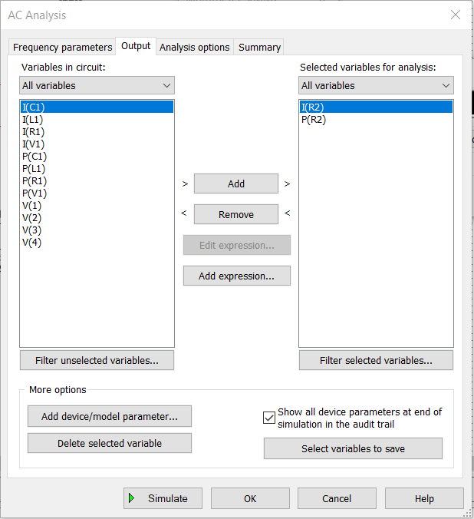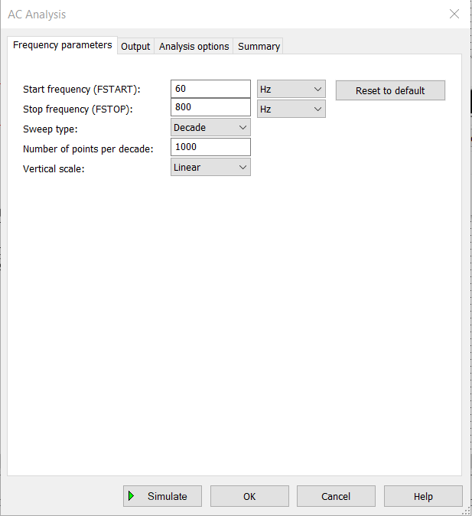

**PARAMETERS FOR CIRCUIT 4**

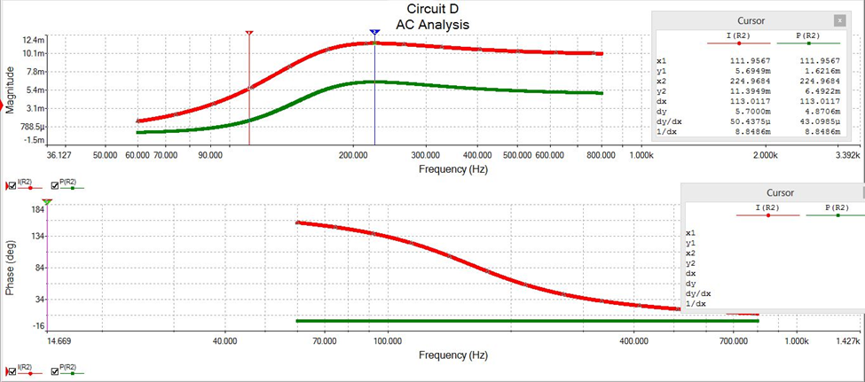

**GRAPH 4**

**The resonant frequency as calculated from the AC analysis of the circuit comes out to be 224.96 Hz. The theoretical value of resonant frequency of the circuit is:**

|  |  |  |  |  |  |  |  |  |  |
| --- | --- | --- | --- | --- | --- | --- | --- | --- | --- |
| Circuit | Resonating frequency | Half Power Frequency | | bandwidth | Q-Factor | Parameters at Resonance | | | |
| F1 | F2 |
| current | Vr | Vl | Vc |
| A | 6.001k | 5.4748k | 6.5834k | 6.9655k | 0.861 | 3.508 | 14.032 | 71.018 | 69.260 |
| B | 157.02 | 96.39 | 235.08 | 871.41 | 0.180 | 0.032 | 3.164 | 6.324 | 7.071 |
| C | 161.00 | 105.44 | 262.66 | 987.80 | 0.162 | 0.032 | 3.224 | 7.071 | 6.293 |
| D | 224.96 | 111.91 | 336.44 | 1410.76 | 0.159 | 0.098 | 8.056 | 8.056 | 6.863 |

We observe that for the given setup of elements in the circuit B and circuit C, we are not able to obtain the resonance frequency. For circuit B, the resonance frequency as calculated is 0. This is due to the value of Resistance offered in both the circuits. By varying the value of resistance in both the circuits, we are able to obtain the point of resonance in both the circuits. The value of changed resistance in both the circuits is kept at 50ohm and the readings are taken accordingly.

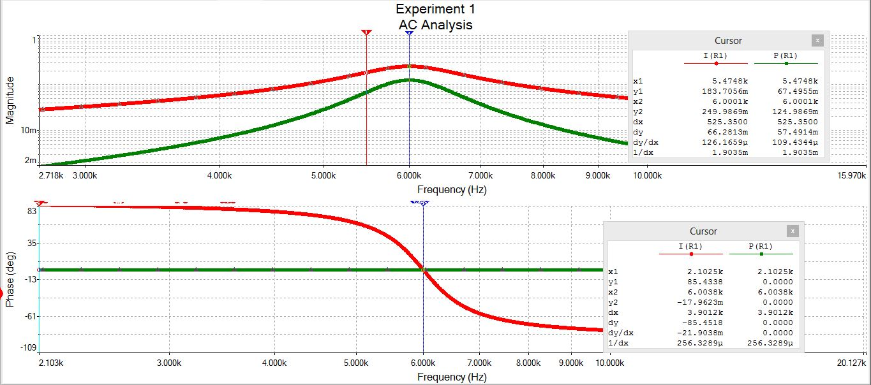

CIRCUIT A

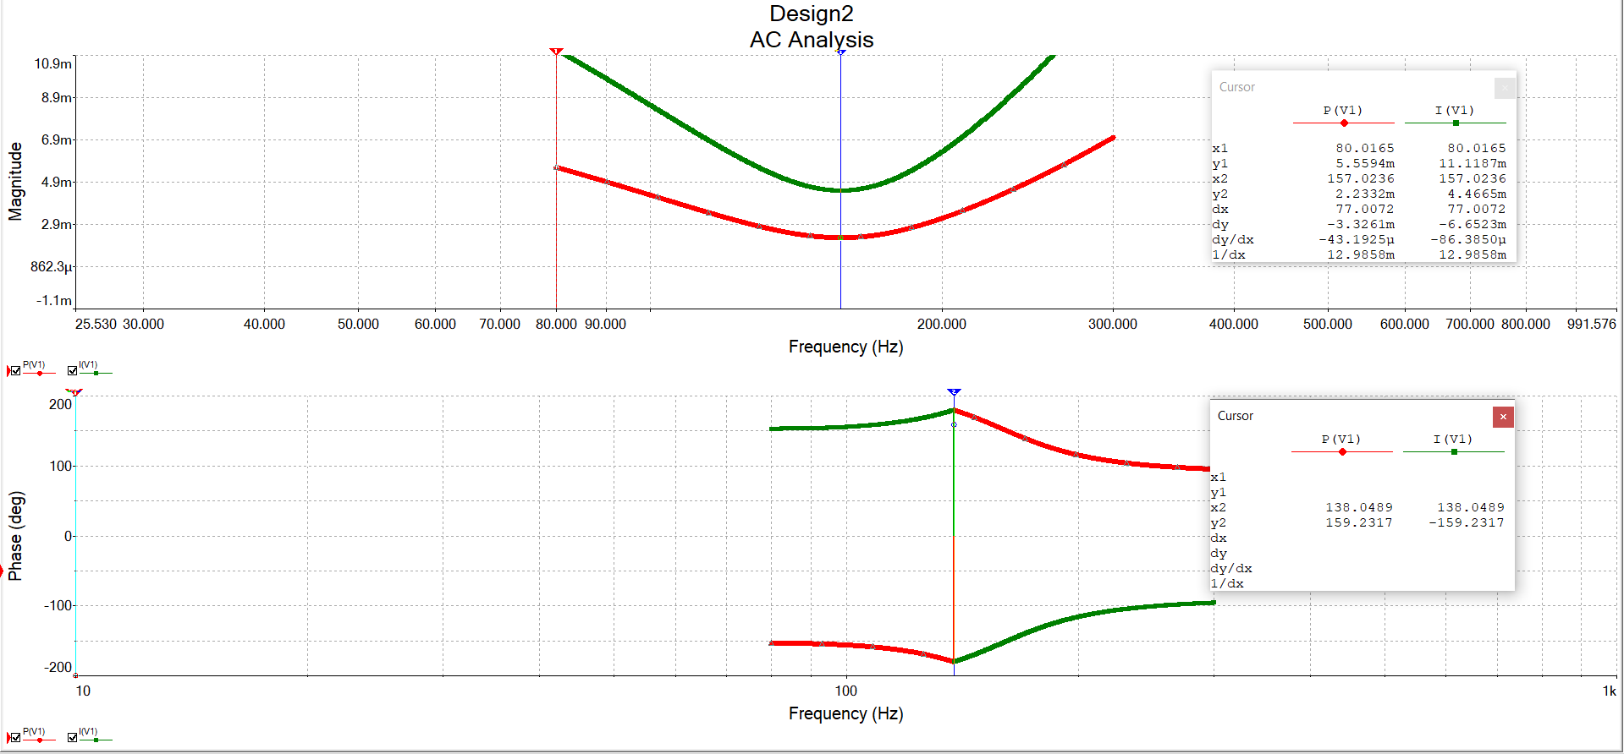

CIRCUIT B

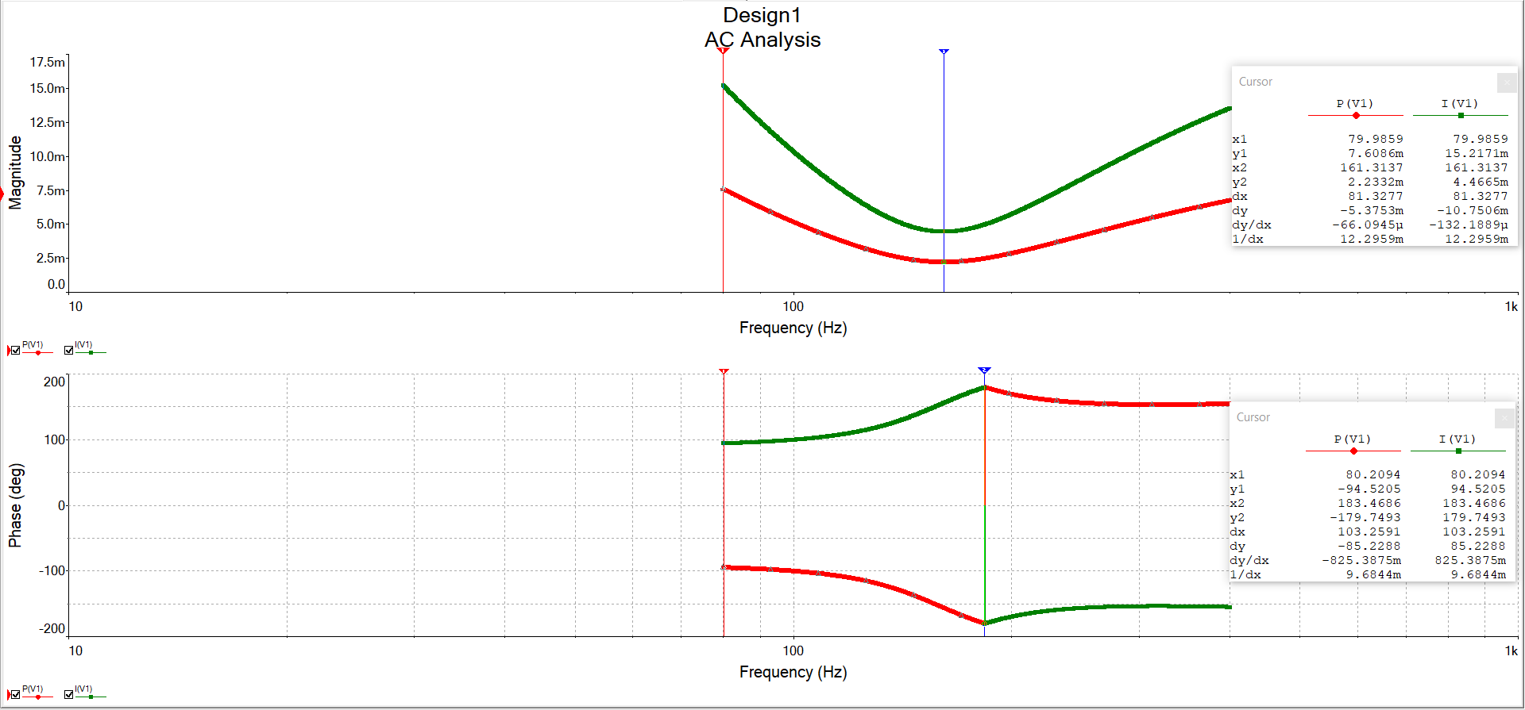

CIRCUIT C

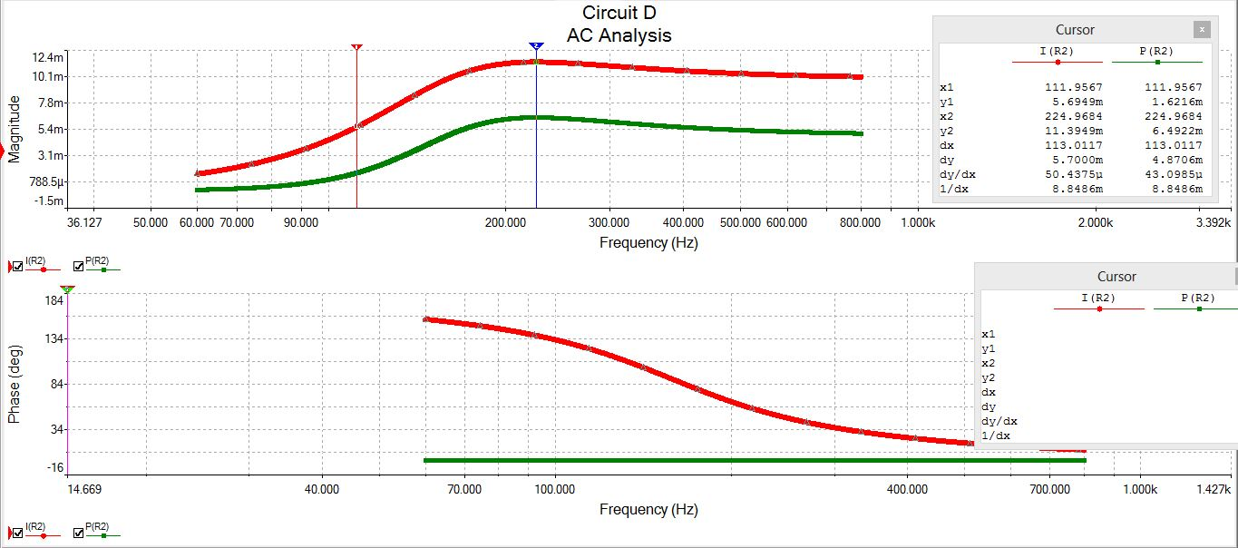

CIRCUIT D

2. Even after the resistor in series with L in the circuit C is removed, the circuit still shows resonance at the same frequency and same bandwidth. The circuit isn’t affected by the removal of the resistor.

3. As given in the phase diagram, the point where I(r1) and P(R1), in series LCR circuit, cross each other, that point if known as the resonant frequency of the circuit and power at that point is maximum for the circuit. Similarly, for parallel LCR circuit, we form a graph between I(V1) and P(V1) and see where both the graphs intersect in the phase diagram. It is the point where the power of the circuit is minimum and this pointy is the resonance point of the circuit.

When the current lags behind the voltage, then the circuit is an Inductive circuit. If the current leads the voltage, then the circuit is a capacitive circuit and when the voltage and current both are in phase, then the circuit is a purely resistive circuit.